Mixed-Integer Linear Program Based Unit Commitment
and Generation Scheduling

Formulation

Cost Functions

For a convex function the formulation is as follows:

Convex function
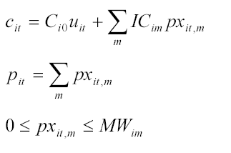

For a non-convex function, the formulation is as follows:

Non-convex function

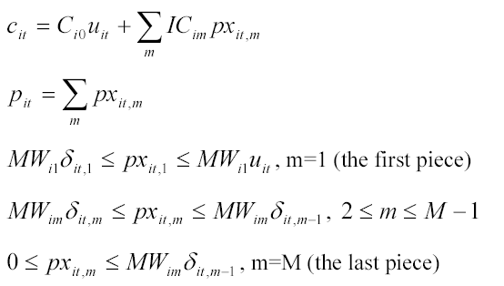

Table 3 below represent the bidding segments and prices for the test case in the assignment. Table 2a represents the test case unit capacities and no-load costs.
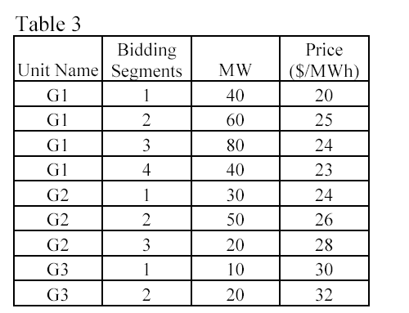
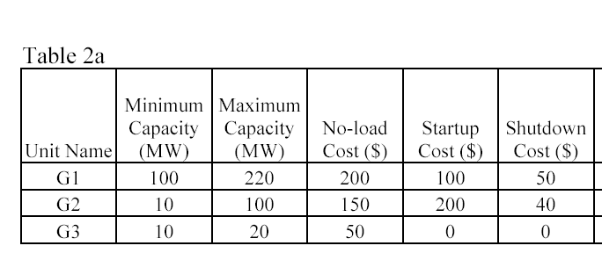

G1 is non-convex, G2 is non-convex, G3 is convex

For G1 at any hour
c_{1,}t = 200u_{1,t} + 20px_{1,t,1} + 25px_{1,t,2} + 24px_{1,t,3} + 23px_{1,t,4}
p_{1,t} = px_{1,t,1} + px_{1,t,2} + px_{1,t,3} + px_{1,t,4}
40δ_{1,t,1} ≤ px_{1,t,1} ≤ 40u_{1,t}
60δ_{1,t,2} ≤ px_{1,t,2} ≤ 60δ_{1,t,2}
80δ_{1,t,3} ≤ px_{1,t,3} ≤ 80δ_{1,t,3}
0 ≤ px_{1,t,4} ≤ 40δ_{1,t,4}

Objective function

f =
u1,1 | p1,1 | px1,1,1 | px1,1,2 | px1,1,3 | px1,1,4 | δ1,1 | δ1,1,1 | δ1,1,2 | δ1,1,3 | δ1,1,4 | y1,1 | z1,1 | sr1,1 | or1,1
200 | 0 | 20 | 25 | 24 | 23 | 0 | 0 | 0 | 0 | 0 | 100 | 50 | 0 | 0

Constraints

 |  | u1,1 | p1,1 | px1,1,1 | px1,1,2 | px1,1,3 | px1,1,4 | δ1,1 | δ1,1,1 | δ1,1,2 | δ1,1,3 | δ1,1,4 | y1,1 | z1,1 | sr1,1 | or1,1
= | 0 | 0 | -1 | 1 | 1 | 1 | 1 | 0 | 0 | 0 | 0 | 0 | 0 | 0 | 0 | 0
E | 0 | 0 | 0 | -1 | 0 | 0 | 0 | 0 | 40 | 0 | 0 | 0 | 0 | 0 | 0 | 0
E | 0 | -40 | 0 | 1 | 0 | 0 | 0 | 0 | 0 | 0 | 0 | 0 | 0 | 0 | 0 | 0
E | 0 | 0 | 0 | 0 | -1 | 0 | 0 | 0 | 0 | 60 | 0 | 0 | 0 | 0 | 0 | 0
E | 0 | 0 | 0 | 0 | 1 | 0 | 0 | 0 | 0 | -60 | 0 | 0 | 0 | 0 | 0 | 0
E | 0 | 0 | 0 | 0 | 0 | -1 | 0 | 0 | 0 | 0 | 80 | 0 | 0 | 0 | 0 | 0
E | 0 | 0 | 0 | 0 | 0 | 1 | 0 | 0 | 0 | 0 | -80 | 0 | 0 | 0 | 0 | 0
E | 0 | 0 | 0 | 0 | 0 | 0 | -1 | 0 | 0 | 0 | 0 | 0 | 0 | 0 | 0 | 0
E | 0 | 0 | 0 | 0 | 0 | 0 | 1 | 0 | 0 | 0 | 0 | -40 | 0 | 0 | 0 | 0

 | u1,1 | p1,1 | px1,1,1 | px1,1,2 | px1,1,3 | px1,1,4 | δ1,1 | δ1,1,1 | δ1,1,2 | δ1,1,3 | δ1,1,4 | y1,1 | z1,1 | sr1,1 | or1,1
lb | 0 | 0 | 0 | 0 | 0 | 0 | 0 | 0 | 0 | 0 | 0 | 0 | 0 | 0 | 0
ub | 1 | inf | inf | inf | inf | inf | 1 | 1 | 1 | 1 | 1 | 1 | 1 | 1 | 1
x | 1 | 0 | 0 | 0 | 0 | 0 | 1 | 1 | 1 | 1 | 1 | 1 | 1 | 1 | 1

For G2 at any hour
c_{2,}t = 150u_{2,t} + 24px_{2,t,1} + 26px_{2,t,2} + 28px_{2,t,3}
p_{2,t} = px_{2,t,1} + px_{2,t,2} + px_{2,t,3}
0 ≤ px_{2,t,1} ≤ 30
0 ≤ px_{2,t,2} ≤ 50
0 ≤ px_{2,t,3} ≤ 20

objective function

f =

 | c_{1,}t | u_{1,t} | p_{1,t} | px_{1,t,1} | px_{1,t,2} | px_{1,t,3} | px_{1,t,4} | δ_{1,t,} | δ_{1,t,1} | δ_{1,t,2} | δ_{1,t,3} | δ_{1,t,4}
= | -1 | 150 | 0 | 24 | 26 | 28 | - | 0 | 0 | 0 | 0 | 0

constraints

 |  | c_{1,}t | u_{1,t} | p_{1,t} | px_{1,t,1} | px_{1,t,2} | px_{1,t,3} | px_{1,t,4} | δ_{1,t,} | δ_{1,t,1} | δ_{1,t,2} | δ_{1,t,3} | δ_{1,t,4}
= | 0 | 0 | 0 | -1 | 1 | 1 | 1 | - | - | - | - | - | -
E | 0 | 0 | 0 | 0 | -1 | 0 | 0 | - | - | - | - | - | -
E | 0 | 0 | 0 | 0 | 0 | -1 | 0 | - | - | - | - | - | -
E | 0 | 0 | 0 | 0 | 0 | 0 | -1 | - | - | - | - | - | -
E | 30 | 0 | 0 | 0 | 1 | 0 | 0 | - | - | - | - | - | -
E | 50 | 0 | 0 | 0 | 0 | 1 | 0 | - | - | - | - | - | -
E | 20 | 0 | 0 | 0 | 0 | 0 | 1 | - | - | - | - | - | -

 |  | c_{1,}t | u_{1,t} | p_{1,t} | px_{1,t,1} | px_{1,t,2} | px_{1,t,3} | px_{1,t,4} | δ_{1,t,} | δ_{1,t,1} | δ_{1,t,2} | δ_{1,t,3} | δ_{1,t,4}
lb |  | 0 | 0 | 0 | 0 | 0 | 0 | - | - | - | - | - | -
ub |  | Inf | 1 | inf | inf | inf | inf | - | - | - | - | - | -
x |  | 0 | 1 | 0 | 0 | 0 | 0 | - | - | - | - | - | -

For G3 at any hour
c_{3,}t = 50u_{3,t} + 30px_{3,t,1} + 32px_{3,t,2}
p_{3,t} = px_{3,t,1} + px_{3,t,2}
0 ≤ px_{2,t,1} ≤ 10
0 ≤ px_{2,t,2} ≤ 20

objective function

f =

 | c_{1,}t | u_{1,t} | p_{1,t} | px_{1,t,1} | Px_{1,t,2} | px_{1,t,3} | px_{1,t,4} | δ_{1,t,} | δ_{1,t,1} | δ_{1,t,2} | δ_{1,t,3} | δ_{1,t,4}
= | -1 | 50 | 0 | 30 | 32 | - | - | 0 | 0 | 0 | 0 | 0

constraints

 |  | c_{1,}t | u_{1,t} | p_{1,t} | px_{1,t,1} | px_{1,t,2} | px_{1,t,3} | px_{1,t,4} | δ_{1,t,} | δ_{1,t,1} | δ_{1,t,2} | δ_{1,t,3} | δ_{1,t,4}
= | 0 | 0 | 0 | -1 | 1 | 1 | - | - | - | - | - | - | -
E | 0 | 0 | 0 | 0 | -1 | 0 | - | - | - | - | - | - | -
E | 0 | 0 | 0 | 0 | 0 | -1 | - | - | - | - | - | - | -
E | 10 | 0 | 0 | 0 | 1 | 0 | - | - | - | - | - | - | -
E | 20 | 0 | 0 | 0 | 0 | 1 | - | - | - | - | - | - | -

 |  | c_{1,}t | u_{1,t} | p_{1,t} | px_{1,t,1} | px_{1,t,2} | px_{1,t,3} | px_{1,t,4} | δ_{1,t,} | δ_{1,t,1} | δ_{1,t,2} | δ_{1,t,3} | δ_{1,t,4}
lb |  | 0 | 0 | 0 | 0 | 0 | - | - | - | - | - | - | -
ub |  | Inf | 1 | inf | inf | inf | - | - | - | - | - | - | -
x |  | 0 | 1 | 0 | 0 | 0 | - | - | - | - | - | - | -

Start-up and shut-down indicators

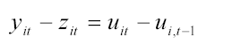

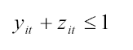

For G1 at any hour
y_{1,t} - z_{1,t} - u_{1,t} + u_{1,(t-1)} = 0
y_{1,t} + z_{1,t} ≤ 1

For G2 at any hour
y_{2,t} – z_{2,t} – u_{2,t} + u_{2,(t-1)} = 0
y_{2,t} + z_{2,t} ≤ 1

For GN at any hour
y_{N,t} – z_{N,t} – u_{N,t} + u_{N,(t-1)} = 0
y_{N,t} + z_{N,t} ≤ 1

Example for G1 for Hours 1 through 4

objective function

f =

 | u_{1,1} | y_{1,1} | z_{1,1} | u_{1,2} | y_{1,2} | z_{1,2} | u_{1,3} | y_{1,3} | z_{1,3} | u_{1,4} | y_{1,4} | z_{1,4}
= | 0 | 0 | 0 | 0 | 0 | 0 | 0 | 0 | 0 | 0 | 0 | 0

constraints

 |  | u_{1,1} | y_{1,1} | z_{1,1} | u_{1,2} | y_{1,2} | z_{1,2} | u_{1,3} | y_{1,3} | z_{1,3} | u_{1,4} | y_{1,4} | z_{1,4}
= | 0 | -1 | 1 | -1 | 0 | 0 | 0 | 0 | 0 | 0 | 0 | 0 | 0
= | 0 | 1 | 0 | 0 | -1 | 1 | -1 | 0 | 0 | 0 | 0 | 0 | 0
= | 0 | 0 | 0 | 0 | 1 | 0 | 0 | -1 | 1 | -1 | 0 | 0 | 0
= | 0 | 0 | 0 | 0 | 0 | 0 | 0 | 1 | 0 | 0 | -1 | 1 | -1
E | 1 | 0 | 1 | 1 | 0 | 0 | 0 | 0 | 0 | 0 | 0 | 0 | 0
E | 1 | 0 | 0 | 0 | 0 | 1 | 1 | 0 | 0 | 0 | 0 | 0 | 0
E | 1 | 0 | 0 | 0 | 0 | 0 | 0 | 0 | 1 | 1 | 0 | 0 | 0
E | 1 | 0 | 0 | 0 | 0 | 0 | 0 | 0 | 0 | 0 | 0 | 1 | 1

For Hour 1
 |  | u1,1 | p1,1 | px1,1,1 | px1,1,2 | px1,1,3 | px1,1,4 | δ1,1 | δ1,1,1 | δ1,1,2 | δ1,1,3 | δ1,1,4 | y1,1 | z1,1 | sr1,1 | or1,1
= | 0 | -1 | 0 | 0 | 0 | 0 | 0 | 0 | 0 | 0 | 0 | 0 | 1 | -1 | 0 | 0
= | 0 | 1 | 0 | 0 | 0 | 0 | 0 | 0 | 0 | 0 | 0 | 0 | 0 | 0 | 0 | 0
= | 0 | 0 | 0 | 0 | 0 | 0 | 0 | 0 | 0 | 0 | 0 | 0 | 0 | 0 | 0 | 0
= | 0 | 0 | 0 | 0 | 0 | 0 | 0 | 0 | 0 | 0 | 0 | 0 | 0 | 0 | 0 | 0
E | 1 | 0 | 0 | 0 | 0 | 0 | 0 | 0 | 0 | 0 | 0 | 0 | 1 | 1 | 0 | 0
E | 1 | 0 | 0 | 0 | 0 | 0 | 0 | 0 | 0 | 0 | 0 | 0 | 0 | 0 | 0 | 0
E | 1 | 0 | 0 | 0 | 0 | 0 | 0 | 0 | 0 | 0 | 0 | 0 | 0 | 0 | 0 | 0
E | 1 | 0 | 0 | 0 | 0 | 0 | 0 | 0 | 0 | 0 | 0 | 0 | 0 | 0 | 0 | 0

For Hour 2

 |  | u1,2 | p1,2 | px1,1,2 | px1,1,2 | px1,1,2 | px1,1,2 | δ1,2 | δ1,1,2 | δ1,2,2 | δ1,2,3 | δ1,2,4 | y1,2 | z1,2 | sr1,2 | or1,2
= | 0 | 0 | 0 | 0 | 0 | 0 | 0 | 0 | 0 | 0 | 0 | 0 | 0 | 0 | 0 | 0
= | 0 | -1 | 0 | 0 | 0 | 0 | 0 | 0 | 0 | 0 | 0 | 0 | 1 | -1 | 0 | 0
= | 0 | 1 | 0 | 0 | 0 | 0 | 0 | 0 | 0 | 0 | 0 | 0 | 0 | 0 | 0 | 0
= | 0 | 0 | 0 | 0 | 0 | 0 | 0 | 0 | 0 | 0 | 0 | 0 | 0 | 0 | 0 | 0
E | 1 | 0 | 0 | 0 | 0 | 0 | 0 | 0 | 0 | 0 | 0 | 0 | 0 | 0 | 0 | 0
E | 1 | 0 | 0 | 0 | 0 | 0 | 0 | 0 | 0 | 0 | 0 | 0 | 1 | 1 | 0 | 0
E | 1 | 0 | 0 | 0 | 0 | 0 | 0 | 0 | 0 | 0 | 0 | 0 | 0 | 0 | 0 | 0
E | 1 | 0 | 0 | 0 | 0 | 0 | 0 | 0 | 0 | 0 | 0 | 0 | 0 | 0 | 0 | 0

For Hour 3

 |  | u1,3 | p1,3 | px1,1,3 | px1,1,3 | px1,1,3 | px1,1,3 | δ1,3 | δ1,3,1 | δ1,3,2 | δ1,3,3 | δ1,3,4 | y1,3 | z1,3 | sr1,3 | or1,3
= | 0 | 0 | 0 | 0 | 0 | 0 | 0 | 0 | 0 | 0 | 0 | 0 | 0 | 0 | 0 | 0
= | 0 | 0 | 0 | 0 | 0 | 0 | 0 | 0 | 0 | 0 | 0 | 0 | 0 | 0 | 0 | 0
= | 0 | -1 | 0 | 0 | 0 | 0 | 0 | 0 | 0 | 0 | 0 | 0 | 1 | -1 | 0 | 0
= | 0 | 1 | 0 | 0 | 0 | 0 | 0 | 0 | 0 | 0 | 0 | 0 | 0 | 0 | 0 | 0
E | 1 | 0 | 0 | 0 | 0 | 0 | 0 | 0 | 0 | 0 | 0 | 0 | 0 | 0 | 0 | 0
E | 1 | 0 | 0 | 0 | 0 | 0 | 0 | 0 | 0 | 0 | 0 | 0 | 0 | 0 | 0 | 0
E | 1 | 0 | 0 | 0 | 0 | 0 | 0 | 0 | 0 | 0 | 0 | 0 | 1 | 1 | 0 | 0
E | 1 | 0 | 0 | 0 | 0 | 0 | 0 | 0 | 0 | 0 | 0 | 0 | 0 | 0 | 0 | 0

 |  | u_{1,1} | y_{1,1} | z_{1,1} | u_{1,2} | y_{1,2} | z_{1,2} | u_{1,3} | y_{1,3} | z_{1,3} | u_{1,4} | y_{1,4} | z_{1,4}
lb |  | 0 | 0 | 0 | 0 | 0 | 0 | 0 | 0 | 0 | 0 | 0 | 0
ub |  | 1 | 1 | 1 | 1 | 1 | 1 | 1 | 1 | 1 | 1 | 1 | 1
x |  | 1 | 1 | 1 | 1 | 1 | 1 | 1 | 1 | 1 | 1 | 1 | 1

Notes: The arrays will be the same pattern for each generator but the combined array will have variables representative of each generator for each hour

For a N Generator system with NT hours, there will be (3)X(N)X(NT) variables and (2)X(N)X(NT) rows. For the test case, 3 generators and 24 hours, there will be 216 variables to represent the start-up and shut-down indicators and 144 rows with constraints.

Combined objective function

f = [G1variables Hour1 G1 variables Hour 2 …. G1 variables Hour NT G2variables Hour1 G2 variables Hour 2 …. G2 variables Hour NT …. GNvariables Hour1 GN variables Hour 2 …. GN variables Hour NT]

Similar procedure as above can be applied to combine the equality and inequality constraints and upper, lower bounds, and integer array.

Start-up and Shut-down Costs
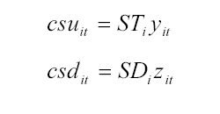

For the test case:

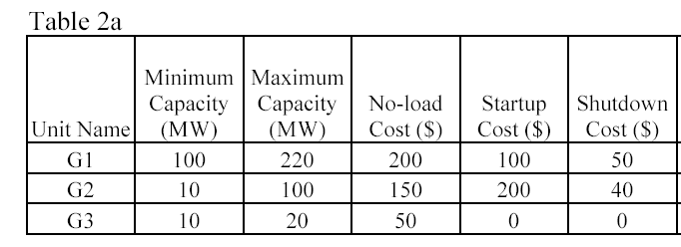

For G1

f =

 | u_{1,1} | y_{1,1} | z_{1,1} | u_{1,2} | y_{1,2} | z_{1,2} | u_{1,3} | y_{1,3} | z_{1,3} | u_{1,4} | y_{1,4} | z_{1,4}
= | 0 | 100 | 50 | 0 | 100 | 50 | 0 | 100 | 50 | 0 | 100 | 50

Similar process is used for G2 and G3 variables in the objective function

Capacities
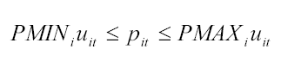

For any hour

G1:
100u_{1,t} ≤ px_{1,t} ≤ 220u_{1,t}
G2
10u_{2,t} ≤ px_{2,t} ≤ 100u_{2,t}
G3
10u_{2,t} ≤ px_{1,t} ≤ 20u_{2,t}

For the first 4 hours for G1

constraints

 |  | u1,1 | p1,1 | px1,1,1 | px1,1,2 | px1,1,3 | px1,1,4 | δ1,1 | δ1,1,1 | δ1,1,2 | δ1,1,3 | δ1,1,4 | y1,1 | z1,1 | sr1,1 | or1,1
0 | 0 | -220 | 1 | 0 | 0 | 0 | 0 | 0 | 0 | 0 | 0 | 0 | 0 | 0 | 0 | 0
0 | 0 | 100 | -1 | 0 | 0 | 0 | 0 | 0 | 0 | 0 | 0 | 0 | 0 | 0 | 0 | 0
0 | 0 | 0 | 0 | 0 | 0 | 0 | 0 | 0 | 0 | 0 | 0 | 0 | 0 | 0 | 0 | 0
0 | 0 | 0 | 0 | 0 | 0 | 0 | 0 | 0 | 0 | 0 | 0 | 0 | 0 | 0 | 0 | 0
0 | 0 | 0 | 0 | 0 | 0 | 0 | 0 | 0 | 0 | 0 | 0 | 0 | 0 | 0 | 0 | 0
0 | 0 | 0 | 0 | 0 | 0 | 0 | 0 | 0 | 0 | 0 | 0 | 0 | 0 | 0 | 0 | 0
0 | 0 | 0 | 0 | 0 | 0 | 0 | 0 | 0 | 0 | 0 | 0 | 0 | 0 | 0 | 0 | 0
0 | 0 | 0 | 0 | 0 | 0 | 0 | 0 | 0 | 0 | 0 | 0 | 0 | 0 | 0 | 0 | 0

 |  | u_{1,1} | px_{1,1} | u_{1,2} | px_{1,2} | u_{1,3} | px_{1,3} | u_{1,4} | px_{1,4}
E | 0 | -220 | 1 | 0 | 0 | 0 | 0 | 0 | 0
E | 0 | 100 | -1 | 0 | 0 | 0 | 0 | 0 | 0
E | 0 | 0 | 0 | -220 | 1 | 0 | 0 | 0 | 0
E | 0 | 0 | 0 | 100 | -1 | 0 | 0 | 0 | 0
E | 0 | 0 | 0 | 0 | 0 | -220 | 1 | 0 | 0
E | 0 | 0 | 0 | 0 | 0 | 100 | -1 | 0 | 0
E | 0 | 0 | 0 | 0 | 0 | 0 | 0 | -220 | 1
E | 0 | 0 | 0 | 0 | 0 | 0 | 0 | 100 | -1

 |  | u_{1,1} | px_{1,1} | u_{1,2} | px_{1,2} | u_{1,3} | px_{1,3} | u_{1,4} | px_{1,4}
lb |  | 0 | 0 | 0 | 0 | 0 | 0 | 0 | 0
ub |  | 1 | inf | 1 | inf | 1 | inf | 1 | inf
x |  | 1 | 0 | 1 | 0 | 1 | 0 | 1 | 0

Note the objective function should remain unchanged for this subpart of the MILP problem

Reserves

Spinning Reserve
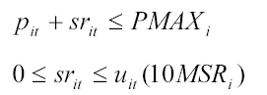

Operating Reserve
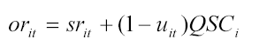

For any hour the test case can be modeled as:

For G1:
p_{1,t} + sr_{1,t} ≤ 220
0 ≤ sr_{1,t,} ≤ u_{1,t}(10*2)
or_{1,t} = sr_{1,t} + (1 – u_{1,t})15

For G2:
p_{2,t} + sr_{2,t} ≤ 100
0 ≤ sr_{2,t,} ≤ u_{2,t}(10*1.5)
or_{2,t} = sr_{2,t} + (1 – u_{2,t})10

For G3:
p_{3,t} + sr_{3,t} ≤ 20
0 ≤ sr_{3,t,} ≤ u_{3,t}(10*0.5)
or_{3,t} = sr_{3,t} + (1 – u_{3,t})10

Example for G1 for Hours 1 through 3

constraints

 |  | u_{1,1} | p_{1,1} | sr_{1,1} | or_{1,1} | u_{1,2} | p_{1,2} | sr_{1,2} | or_{1,2} | u_{1,3} | p_{1,3} | sr_{1,3} | or_{1,3}
= | 15 | 15 | 0 | -1 | 1 | 0 | 0 | 0 | 0 | 0 | 0 | 0 | 0
E | 220 | 0 | 1 | 1 | 0 | 0 | 0 | 0 | 0 | 0 | 0 | 0 | 0
E | 0 | -10*2 | 0 | 1 | 0 | 0 | 0 | 0 | 0 | 0 | 0 | 0 | 0
E | 0 | 0 | 0 | -1 | 0 | 0 | 0 | 0 | 0 | 0 | 0 | 0 | 0
= | 15 | 0 | 0 | 0 | 0 | 15 | 0 | -1 | 1 | 0 | 0 | 0 | 0
E | 220 | 0 | 0 | 0 | 0 | 0 | 1 | 1 | 0 | 0 | 0 | 0 | 0
E | 0 | 0 | 0 | 0 | 0 | -10*2 | 0 | 1 | 0 | 0 | 0 | 0 | 0
E | 0 | 0 | 0 | 0 | 0 | 0 | 0 | -1 | 0 | 0 | 0 | 0 | 0
= | 15 | 0 | 0 | 0 | 0 | 0 | 0 | 0 | 0 | 15 | 0 | -1 | 1
E | 220 | 0 | 0 | 0 | 0 | 0 | 0 | 0 | 0 | 0 | 1 | 1 | 0
E | 0 | 0 | 0 | 0 | 0 | 0 | 0 | 0 | 0 | -10*2 | 0 | 1 | 0
E | 0 | 0 | 0 | 0 | 0 | 0 | 0 | 0 | 0 | 0 | 0 | -1 | 0

 |  | u1,1 | p1,1 | px1,1,1 | px1,1,2 | px1,1,3 | px1,1,4 | δ1,1 | δ1,1,1 | δ1,1,2 | δ1,1,3 | δ1,1,4 | y1,1 | z1,1 | sr1,1 | or1,1
0 | 0 | -220 | 1 | 0 | 0 | 0 | 0 | 0 | 0 | 0 | 0 | 0 | 0 | 0 | 0 | 0
0 | 0 | 100 | -1 | 0 | 0 | 0 | 0 | 0 | 0 | 0 | 0 | 0 | 0 | 0 | 0 | 0
0 | 0 | 0 | 0 | 0 | 0 | 0 | 0 | 0 | 0 | 0 | 0 | 0 | 0 | 0 | 0 | 0
0 | 0 | 0 | 0 | 0 | 0 | 0 | 0 | 0 | 0 | 0 | 0 | 0 | 0 | 0 | 0 | 0
0 | 0 | 0 | 0 | 0 | 0 | 0 | 0 | 0 | 0 | 0 | 0 | 0 | 0 | 0 | 0 | 0
0 | 0 | 0 | 0 | 0 | 0 | 0 | 0 | 0 | 0 | 0 | 0 | 0 | 0 | 0 | 0 | 0
0 | 0 | 0 | 0 | 0 | 0 | 0 | 0 | 0 | 0 | 0 | 0 | 0 | 0 | 0 | 0 | 0
0 | 0 | 0 | 0 | 0 | 0 | 0 | 0 | 0 | 0 | 0 | 0 | 0 | 0 | 0 | 0 | 0

 |  | u_{1,1} | p_{1,1} | sr_{1,1} | or_{1,1} | u_{1,2} | p_{1,2} | sr_{1,2} | or_{1,2} | u_{1,3} | p_{1,3} | sr_{1,3} | or_{1,3}
lb |  | 0 | 0 | 0 | 0 | 0 | 0 | 0 | 0 | 0 | 0 | 0 | 0
ub |  | 1 | Inf | 1 | 1 | 1 | inf | 1 | 1 | 1 | inf | 1 | 1
x |  | 1 | 0 | 1 | 1 | 1 | 0 | 1 | 1 | 1 | 0 | 1 | 1

Ramping Constraints

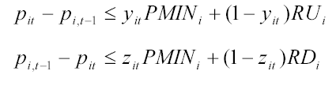

For the test case

G1 at any hour
p_{1,t} – p_{1,t-1} ≤ y_{1,t}100 + (1-y_{1,t})40
p_{1,t-1} – p_{1,t} ≤ z_{1,t}100 + (1-z_{1,t})50

G2 at any hour
p_{2,t} – p_{2,t-1} ≤ y_{2,t}10 + (1-y_{2,t})30
p_{2,t-1} – p_{2,t} ≤ z_{2,t}10 + (1-z_{2,t})25

G3 at any hour
p_{3,t} – p_{3,t-1} ≤ y_{3,t}10 + (1-y_{3,t})20
p_{3,t-1} – p_{3,t} ≤ z_{3,t}10 + (1-z_{3,t})20

Example for G1 for Hours 1 through 4

constraints

 |  | p_{1,1} | y_{1,1} | z_{1,1} | p_{1,2} | y_{1,2} | z_{1,2} | p_{1,3} | y_{1,3} | z_{1,3} | p_{1,4} | y_{1,4} | z_{1,4}
E | 40 | 1 | -(100-40) | 0 | 0 | 0 | 0 | 0 | 0 | 0 | 0 | 0 | 0
E | 50 | -1 | 0 | -(100-50) | 0 | 0 | 0 | 0 | 0 | 0 | 0 | 0 | 0
E | 40 | -1 | 0 | 0 | 1 | -(100-40) | 0 | 0 | 0 | 0 | 0 | 0 | 0
E | 50 | 1 | 0 | 0 | -1 | 0 | -(100-50) | 0 | 0 | 0 | 0 | 0 | 0
E | 40 | 0 | 0 | 0 | -1 | 0 | 0 | 1 | -(100-40) | 0 | 0 | 0 | 0
E | 50 | 0 | 0 | 0 | 1 | 0 | 0 | -1 | 0 | -(100-50) | 0 | 0 | 0
E | 40 | 0 | 0 | 0 | 0 | 0 | 0 | -1 | 0 | 0 | 1 | -(100-40) | 0
E | 50 | 0 | 0 | 0 | 0 | 0 | 0 | 1 | 0 | 0 | -1 | 0 | -(100-50)

Minimum Up/Down Time
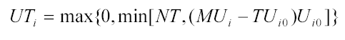
Minimum Up Time

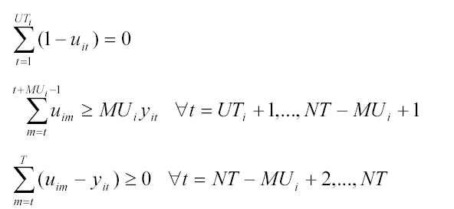

For G1
Initial status on for 4 hours
UT = max{0,min[24,(4-4)1]}

Minimum Down Time
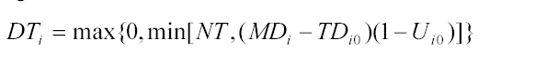

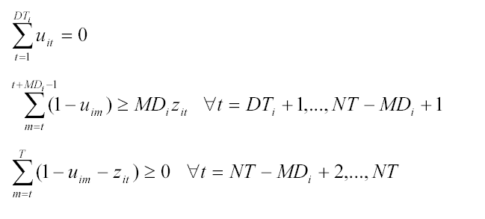

System Load Balance and Reserve Requirements
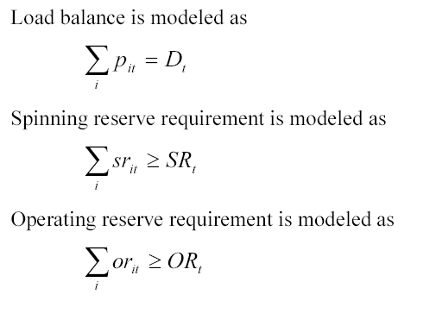

Example for G1 and G2 for Hours 1 through 2

objective function

constraints

 |  | p_{1,1} | sr_{1,1} | or_{1,1} | p_{1,2} | sr_{1,2} | or_{1,2} | p_{2,1} | sr_{2,1} | or_{,21} | p_{2,2} | sr_{2,2} | or_{2,2}
= | -D1 | 1 | 0 | 0 | 0 | 0 | 0 | 1 | 0 | 0 | 0 | 0 | 0
= | -D2 | 0 | 0 | 0 | 1 | 0 | 0 | 0 | 0 | 0 | 1 | 0 | 0
E | -SR1 | 0 | -1 | 0 | 0 | 0 | 0 | 0 | -1 | 0 | 0 | 0 | 0
E | -SR2 | 0 | 0 | 0 | 0 | -1 | 0 | 0 | 0 | 0 | 0 | -1 | 0
E | -OR1 | 0 | 0 | -1 | 0 | 0 | 0 | 0 | 0 | -1 | 0 | 0 | 0
E | -OR2 | 0 | 0 | 0 | 0 | 0 | -1 | 0 | 0 | 0 | 0 | 0 | -1

